**Loops**

Loops are structures that allow you to repeat a block of code multiple times. Here are the most commonly used loops in JavaScript:

**1. "for" Loop:**

The "for" loop is used when you know beforehand how many times you want to execute a block of code.

**Example:**

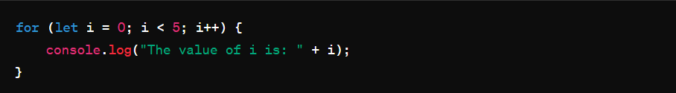

**This loop will print:**

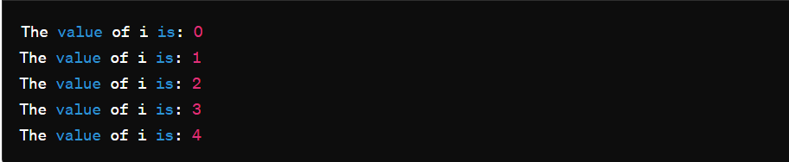

**2. "while" Loop:**

The "while" loop is used when you want to execute a block of code as long as a condition is true. It's useful when you don't know beforehand how many times the loop will run.

**Example:**

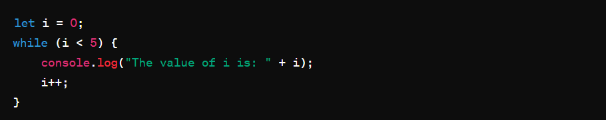

**This loop will also print:**

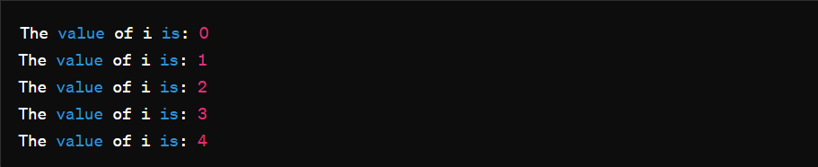

**3. "do-while" Loop:**

The "do-while" loop is similar to the "while" loop, but it always executes the block of code at least once before checking the condition.

**Example:**

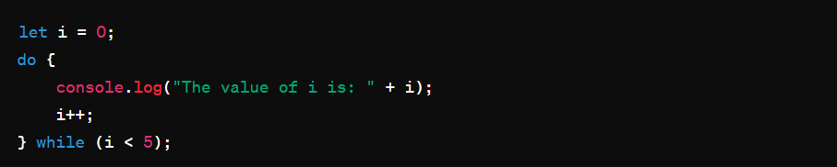

**This loop will also print:**



**Loop Control Statements:**

JavaScript also provides loop control statements to alter the execution flow within loops.

* **"break"** statement: It terminates the loop immediately, even if the condition for its execution is still true.

**Examples:**

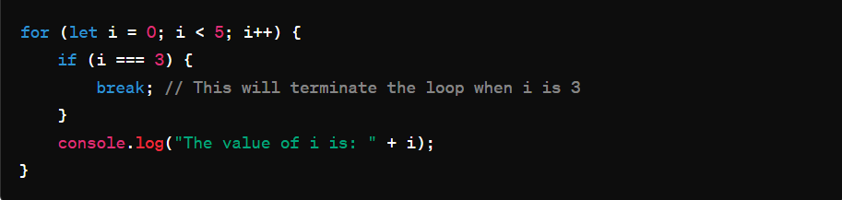

**This loop will also print:**

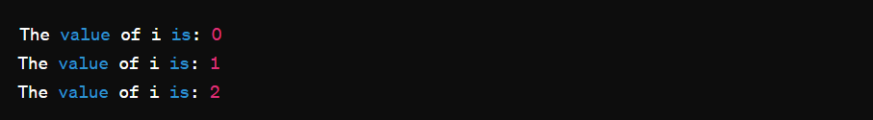

* **"continue"** statement: It skips the current iteration of the loop and continues with the next iteration.

**Example:**

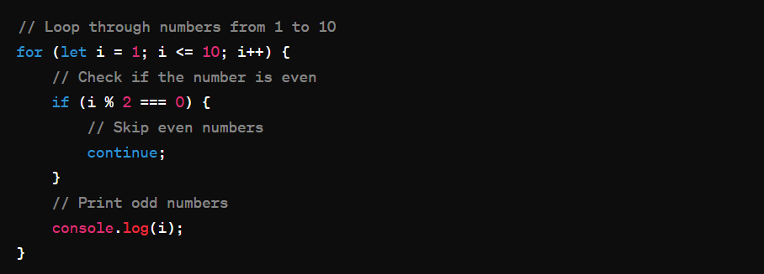

In this example, the loop iterates from 1 to 10. Inside the loop, it checks if the current number (‘i’) is even. If it is, the continue statement is executed, which skips the rest of the loop body for that iteration and moves on to the next iteration. As a result, only odd numbers will be printed to the console

**This loop will also print:**

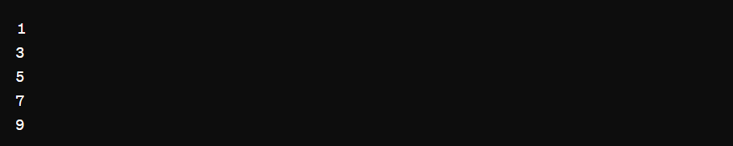

* The loop iterates from 1 to 10.
* For each iteration, it checks if the current number is even.
* If the number is even, it skips the rest of the loop body and moves to the next iteration.
* If the number is odd, it prints the number to the console.
* Therefore, only odd numbers (1, 3, 5, 7, 9) will be printed to the console.